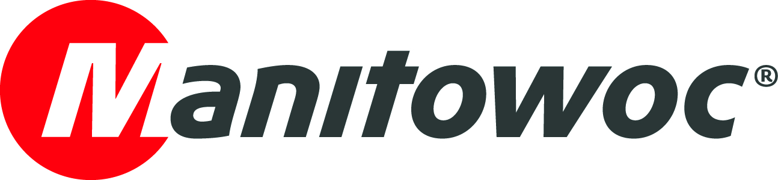
NEWS RELEASE

May 5, 2021

New Potain MDT 489 topless crane offers high capacity with low operating costs

- The Potain MDT 489 can lift a maximum of 22 USt (20 t) or 27.6 USt (25 t) within a 262 ft (80 m) radius and be configured in multiple ways to make best use of the space and equipment available on the jobsite.
- The topless tower crane is simple to transport in standard containers, requiring four to five fewer containers than other cranes of the same size, and can be assembled in half the time, thanks to thoughtful design and Manitowoc’s Crane Control System (CCS).
- The combination of high capacity, compact configuration, ease of transport and optimized assembly and disassembly make the Potain MDT 489 the new lifting leader in the 450 mt category.

The new Potain MDT 489 topless crane from Manitowoc fills the gap between the manufacturer’s popular MDT 389 and new MDT 569 models and is ideal for large-scale construction and infrastructure projects, especially the installation of large, prefabricated components, as well as for shipyards and mines with heavy loads to handle.

The MDT 489 delivers a high capacity with a maximum load of 22 USt (20 t) or 27.6 USt (25 t) and a 262 ft (80 m) jib for broad coverage and reach on the jobsite — all while offering the cost-saving benefits of easy transport and quick assembly and disassembly.

In addition, its compact crane configuration enables it to operate on tight and congested sites. The MDT 489 has been designed for high performance, while keeping the concept of using topless technologies that overlap and avoid collisions on jobsites with multiple cranes, unlike hammerhead tower crane models.

Engineered for exceptionally compact transport

All components, save the slewing mechanism, can be transported in standard-sized shipping containers. The rotating section of the MDT 489 can be transported in just nine containers. That is four or five fewer than needed for a typical crane of this size, decreasing transport cost and complexity, as well as making access to the jobsite much simpler. Protective packaging with brackets helps secure the jib sections and cushioning pads within the containers protect the sections while facilitating efficient packing.

Unmatched assembly speed in its category

When the MDT 489 arrives at the jobsite, it is twice as quick to assemble as other cranes of a similar size. With a 262 ft (80 m) jib and 164 ft (50 m) mast, assembly takes a maximum of two days and requires very little space.

The MDT 489 can be placed on a 19.6 ft (6 m) or 26.2 ft (8 m) cross base platform and assembled in various configurations to best use the space and equipment available on the jobsite. The jib has been designed for easy and efficient erection with built-in slinging points. The jib sections can be assembled in different configurations to offer jobsite flexibility according to the assist crane size and ground space available. The heaviest jib section weighs only 7.39 USt (6,7 t). The rotating cab and thoughtful design of the counter-jib connection points also make for easy mounting.

Latest Potain technologies maximize performance

Using Manitowoc’s Crane Control System (CCS), the MDT 489 can be set up in just 15 minutes. Moreover, this feature promotes highly controlled and efficient operation throughout the crane’s time on the jobsite. The trolley offers two falls for fast duty-cycle lifting or four falls for heavy lifting. The wire ropes for the trolley can be tensioned and then the sensor recalibrated simply by using a push-button inside the operator cab. This is ideal for long-term jobsites that require more frequent tensioning. Once the MDT 489 has completed its work on the jobsite, it can be quickly and easily disassembled, ready to make way for other cranes or move on to its next job.

Customers have the option of the new high-performance 110 HPL winch or the 150 HPL. (The 132 HPL and 180 HPL are available for the North American market). Productivity is dramatically increased with the new 110 HPL winch, as lifting speeds are up to twice that of the older 100 LVF winch. This feature, in combination with new motor brake management and a new architecture that facilitates maintenance operations, means the 110 HPL winch speed up construction times, improve overall driving comfort and provide more precise load placement. These performance improvements do not increase power consumption, and maintenance is easier. Additionally, with the Power Control functionality, it is possible to limit the maximum electric power required for the crane operation without impacting low-load and no-load working speeds.

Like all Potain CCS cranes, the MDT 489 is equipped with the CraneSTAR Diag solution. Potain's remote diagnostic tool allows the customer to consult the machine's activity in real time. Thanks in particular to the forecasting of maintenance operations and advanced diagnostic assistance, the customer optimizes the availability of its cranes and the return on investment. The recovery of operating data allows the measurement of the crane utilization and load rates in order to optimize productivity and operational efficiency on construction sites.

The Potain MDT 489 topless crane has the most highly optimized assembly and disassembly process for a crane in the 450 mt category and helps to save costs while enjoying the benefits of a high-capacity crane. It combines the capacity necessary for large construction projects with a compact crane configuration for the tightest and most congested jobsites, enabling contractors to access more sites and complete the job efficiently and profitably.

Visit the Manitowoc website to discover more about the Potain MDT 489 topless crane.

-END-

CONTACT
Dominique Leullier
Marketing Director Europe
Manitowoc
+ 33 4 72 18 21 60
dominique.leullier@manitowoc.com

ABOUT THE MANITOWOC COMPANY, INC.
The Manitowoc Company, Inc. was founded in 1902 and has over a 118-year tradition of providing high-quality, customer-focused products and support services to its markets. Manitowoc is one of the world's leading providers of engineered lifting solutions. Manitowoc, through its wholly-owned subsidiaries, designs, manufactures, markets, and supports comprehensive product lines of mobile telescopic cranes, lattice-boom crawler cranes, boom trucks, tower cranes, and industrial cranes under the Grove, Manitowoc, National Crane, Potain and Shuttlelift brand names.

THE MANITOWOC COMPANY, INC.
One Park Plaza — 11270 West Park Place — Suite 1000 — Milwaukee, WI 53224, USA
T +1 414 760 4600
www.manitowoc.com

